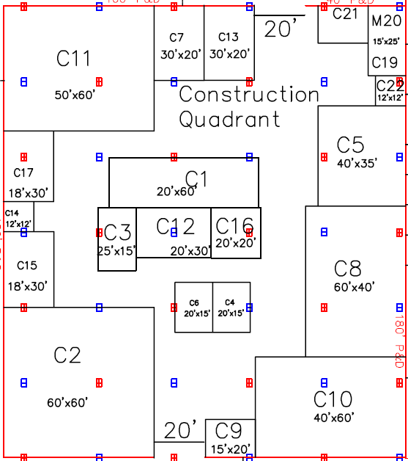

18 GRCC Educator Table

19 West Michigan Works!

20 Community Reinvestment Association Banks

21 Grand Rapids Community College

22 Atomic Object

12 Service Professor

13 Michigan Regional Council of Carpenters

14 Control Solutions Inc

15 Ambient Architecture, AIA Grand Rapids, Progressive Companies, TowerPinkster, Kendall College

16 Fleis & VandenBrink Engineering, Inc.

17 ROWE Professional Services Company

1 West Michigan Plumbers Fitters and Service Trades Local #174

2 City of Grand Rapids, City of Wyoming, City of Kentwood, City of Walker, Kent County Road Commission

3 Quality Air Heating & Cooling, Inc

4 Michigan Department of Transportation

5 Operating Engineers 324

6 Händorn Inc.

7 The Bouma Corporation

8 Feyen Zylstra, IBEW 275, Windemuller

9 Kent Power

10 MEWDC, Consumers Energy, DTE

11 Triangle Associates, Inc., Rockford Construction, Rhode Construction, The Christman Co., Rieth Riley Construction & Dan Vos Construction